**Initial Project Planning Template**

|  |  |
| --- | --- |
| Date | 8 July 2024 |
| Team ID | SWTID1720162737 |
| Project Name | Predicting Compressive Strength of Concrete Using Machine Learning |
| Maximum Marks | 4 Marks |

**Product Backlog, Sprint Schedule, and Estimation (4 Marks)**

Use the below template to create a product backlog and sprint schedule

|  |  |  |  |  |  |  |  |  |
| --- | --- | --- | --- | --- | --- | --- | --- | --- |
| **Sprint** | **Functional**  **Requirement (Epic)** | **User Story Number** | **User Story / Task** | **Story Points** | **Priority** | **Team Members** | **Sprint Start Date** | **Sprint End**  **Date**  **(Planned)** |
| Sprint-1 | Project initialization | USN-2 | Research and gather data on concrete composition and properties. | 2 | High | Veda Sri | 04/07/2024 | 08/07/2024 |
| Sprint-1 | Project initialization | USN-3 | Identify relevant features affecting compressive strength | 1 | High | Veda Sri | 04/07/2024 | 08/07/2024 |
| Sprint-1 | Project initialization | USN-4 | Collect the dataset | 2 | Low | Renu Vaishnavi | 04/07/2024 | 08/07/2024 |

|  |  |  |  |  |  |  |  |  |
| --- | --- | --- | --- | --- | --- | --- | --- | --- |
| Sprint-2 | Data collection and  Preprocessing | USN-6 | Clean the raw data to remove inconsistencies and errors. | 2 | Medium | Renu Vaishnavi | 05/07/2024 | 09/07/2024 |
| Sprint-2 | Data collection and  Preprocessing | USN-7 | Handle missing values and perform imputation if necessary. | 1 | High | Sathwik | 05/07/2024 | 09/07/2024 |
| Sprint-2 | Data collection and  Preprocessing | USN-8 | Perform feature scaling and normalization. | 1 | Medium | Sathwik | 05/07/2024 | 09/07/2024 |
| Sprint-2 | Data collection and  Preprocessing | USN-9 | Encode categorical variables. | 2 | Medium | Sri Sai | 05/07/2024 | 09/07/2024 |
| Sprint-3 | Model Building | USN-11 | Split the dataset into training, validation, and test sets. | 2 | Medium | Sri Sai | 06/07/2024 | 10/07/2024 |
| Sprint-3 | Model Building | USN-12 | Select and implement baseline machine learning algorithms. | 1 | High | Veda Sri | 06/07/2024 | 10/07/2024 |
| Sprint-4 | Model Building | USN-14 | Perform hyperparameter tuning to optimize model performance. | 2 | Medium | Veda Sri | 07/07/2024 | 11/07/2024 |
| Sprint-4 | Model Building | USN-15 | Prepare a deployment plan and deploy the model. | 1 | High | Renu Vaishnavi | 07/07/2024 | 11/07/2024 |
| Sprint-5 | Application Building | USN-16 | Compare different machine learning models to select the best one. | 1 | Medium | Renu Vaishnavi | 07/07/2024 | 11/07/2024 |
| Sprint-5 | Application Building | USN-18 | Evaluate model performance using appropriate metrics. | 2 | Medium | Veda Sri | 07/07/2024 | 11/07/2024 |
| Sprint-6 | Application Building | USN-20 | Validate the model using the validation dataset. | 2 | High | Sri Sai | 08/07/2024 | 11/07/2024 |
| Sprint-6 | Application Building | USN-22 | Development of HTML pages | 2 | Medium | Sathwik | 08/07/2024 | 11/07/2024 |
| Sprint-7 | Project report | USN-23 | Completion of Project report | 2 | Medium | Sathwik | 05/07/2024 | 11/07/2024 |

Sprint – 1:

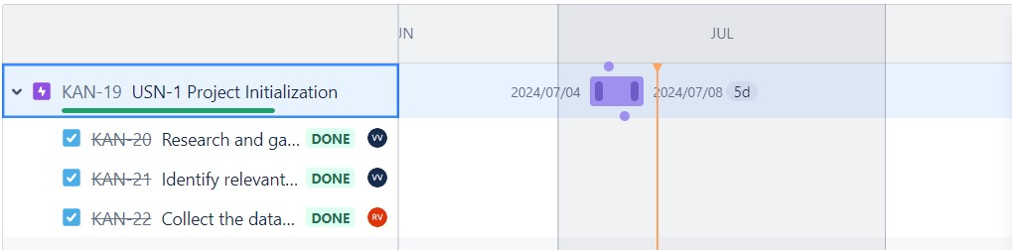

Sprint – 2&3:

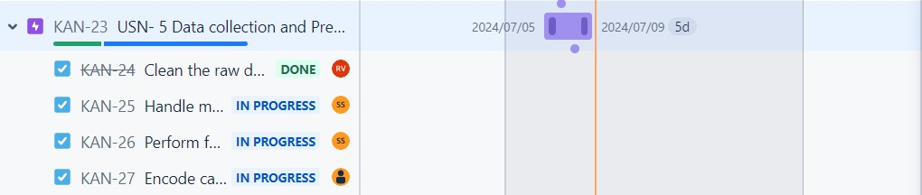

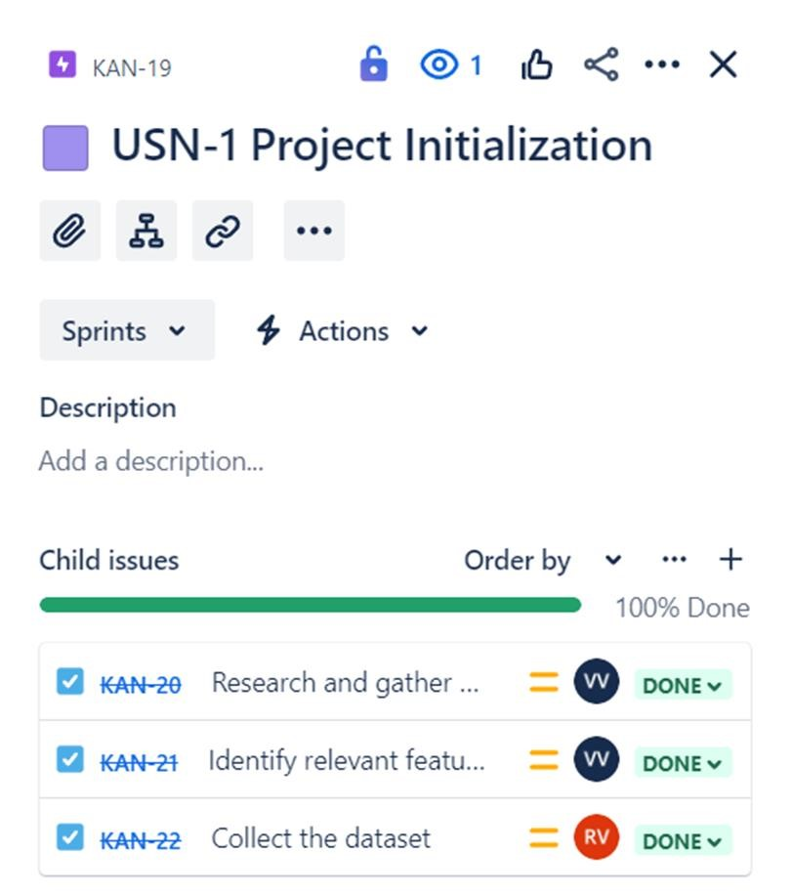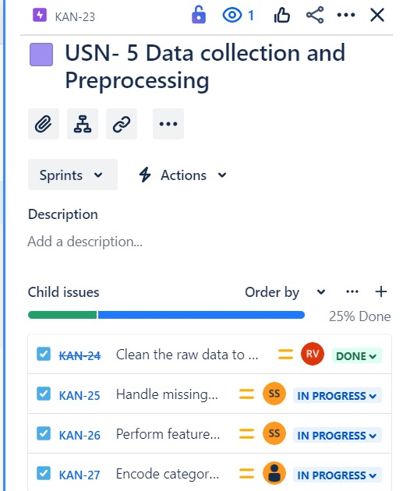

Sprint – 4&5: 

Sprint – 6&7:

